**LIT TRAINING**

Name: Pataparla Thanusha

Employee ID:46255251

Interface:

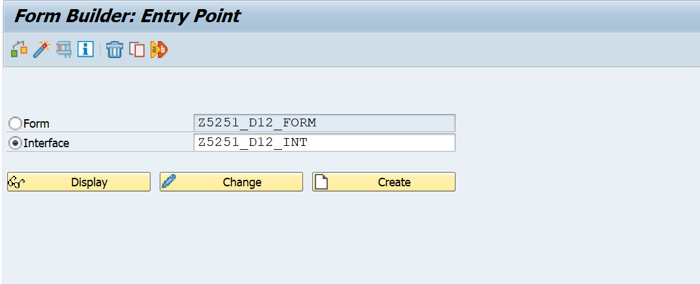

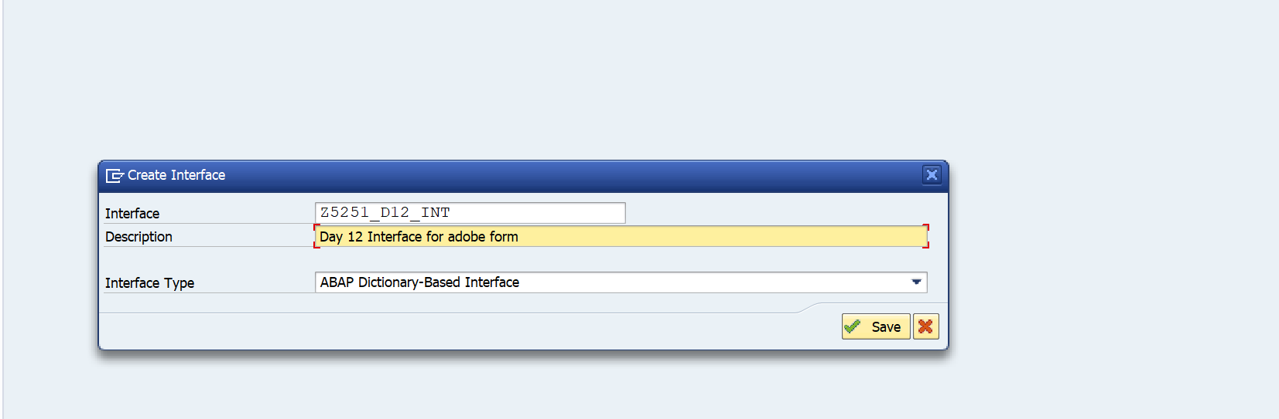

Declaring dynamic text:

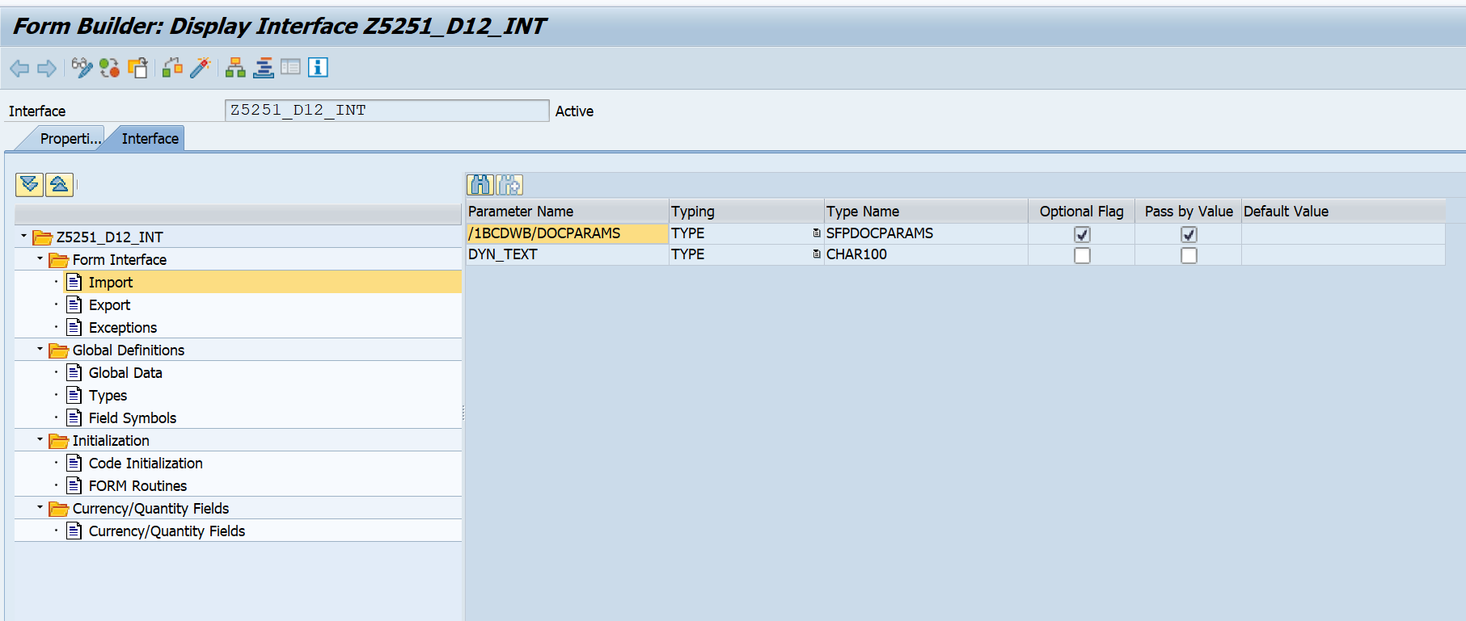

se78- uploading image

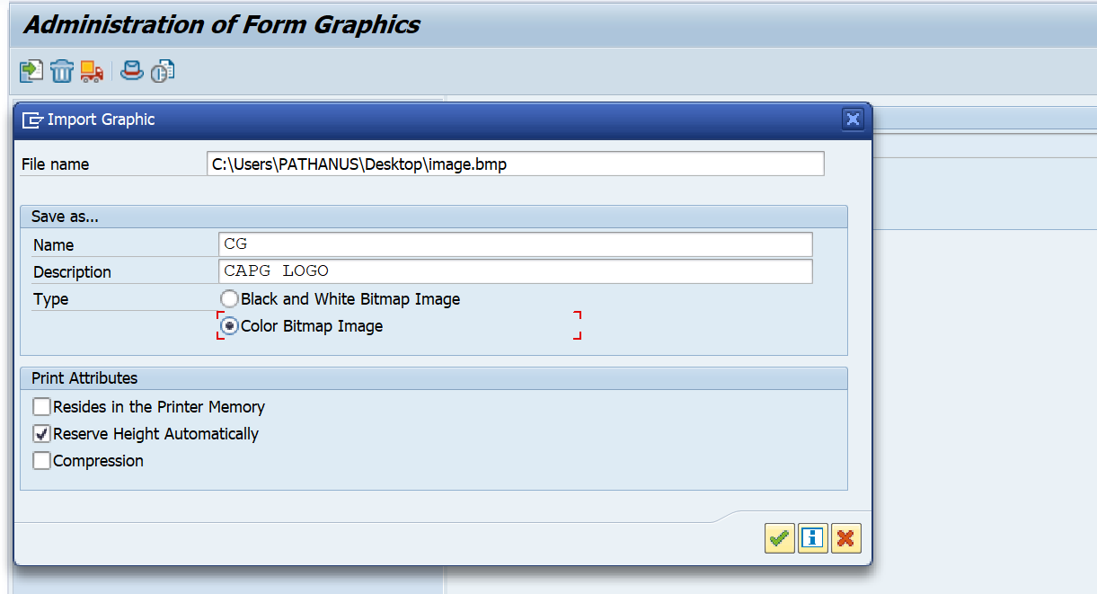

Global data in interface:

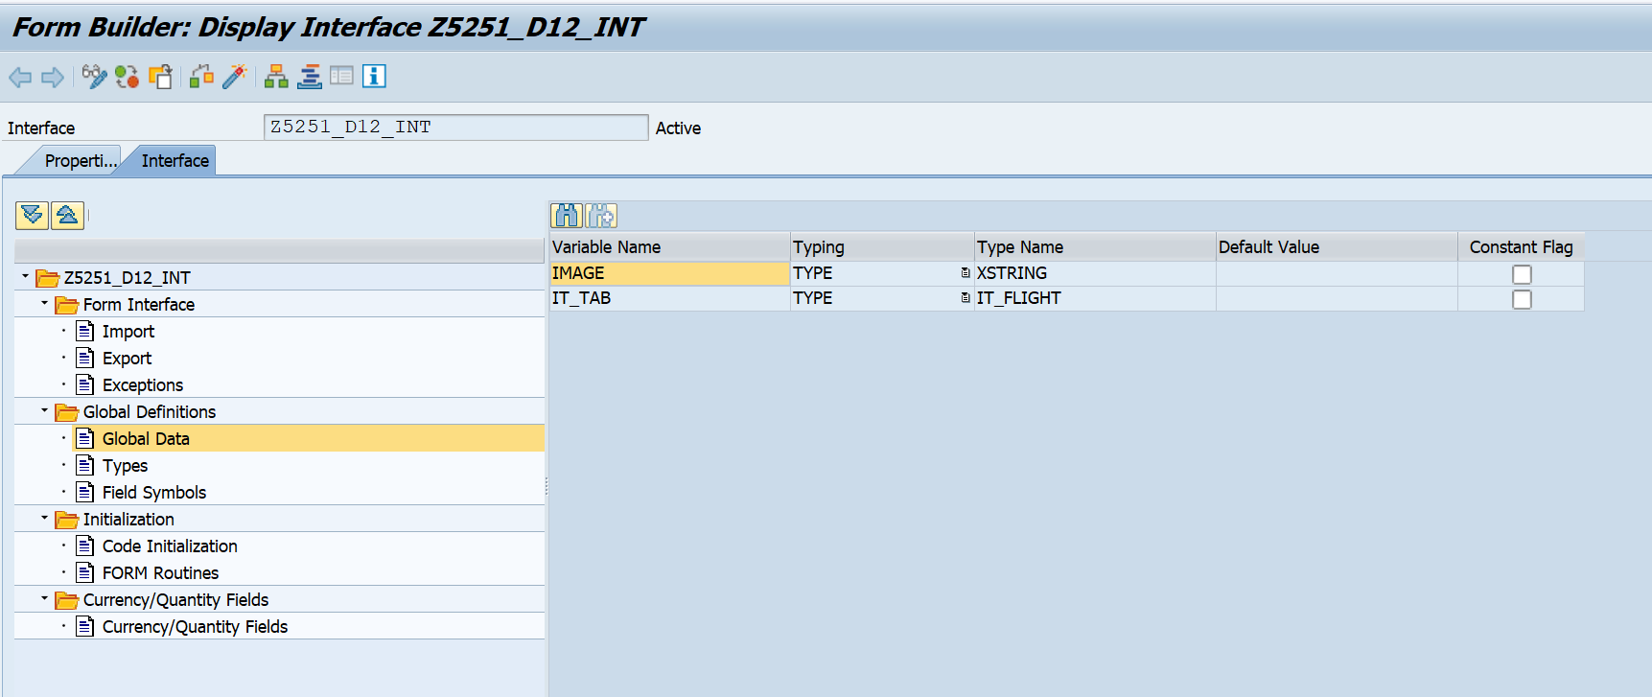

Structure and table type:

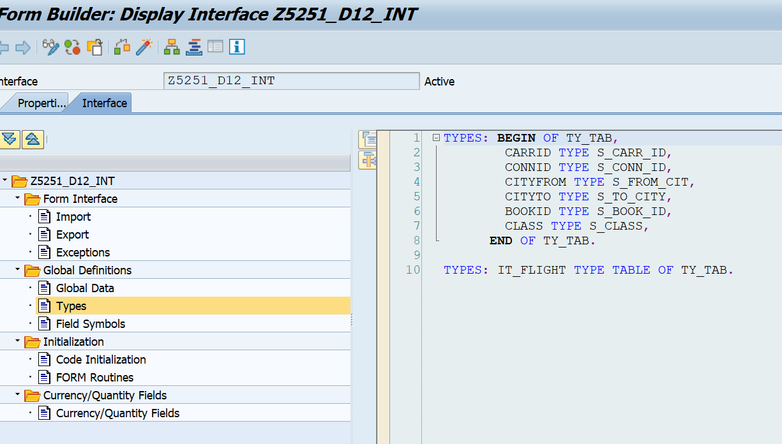

Code initialization:

CALL METHOD CL_SSF_XSF_UTILITIES=>GET_BDS_GRAPHIC_AS_BMP  
  EXPORTING  
    P_OBJECT       = 'GRAPHICS'  
    P_NAME         = 'CG'  
    P_ID           = 'BMAP'  
    P_BTYPE        = 'BCOL'  
  RECEIVING  
    P_BMP          = IMAGE  
  EXCEPTIONS  
    NOT_FOUND      = 1  
    INTERNAL_ERROR = 2  
    OTHERS         = 3  
        .  
IF SY-SUBRC <> 0.  
* Implement suitable error handling here  
ENDIF.  
  
  
  SELECT  
  
  A~CARRID  A~CONNID B~CITYFROM B~CITYTO C~BOOKID C~CLASS  
  FROM SFLIGHT AS A INNER JOIN SPFLI AS B ON A~CARRID EQ B~CARRID  
  INNER JOIN SBOOK AS C ON B~CARRID EQ C~CARRID INTO TABLE IT_TAB UP TO 50 ROWS.

Form:

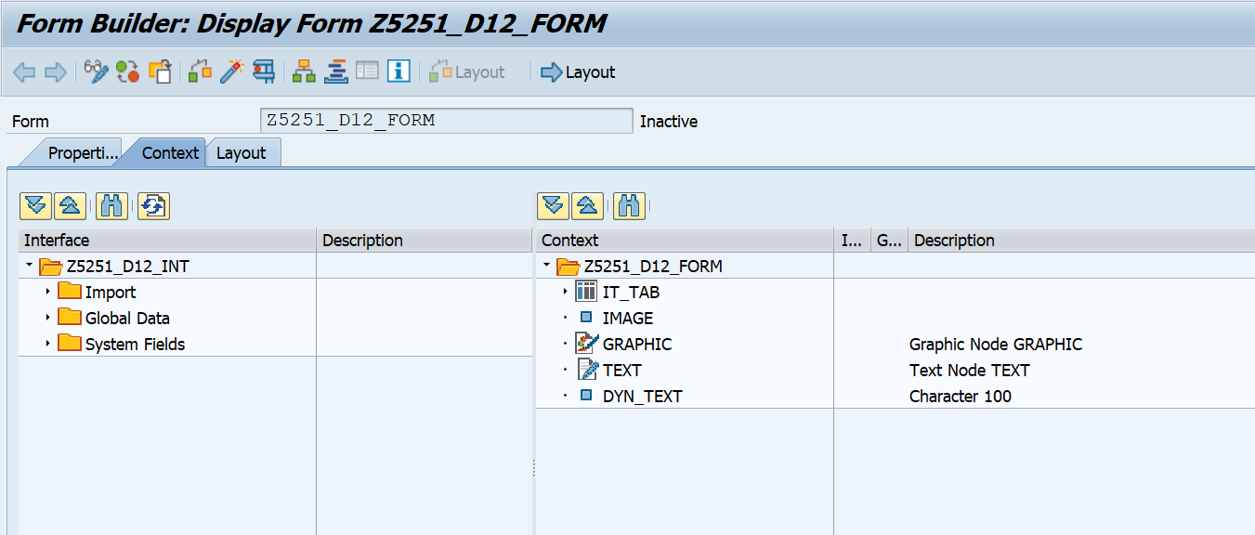

Code for header in only first page:

var curpage = $layout.page ( ref ( $ ) )

if ( curpage ne 1 ) then

$.presence = "hidden"

endif

Code for footer in only last page:

var curp = $layout.page ( ref ( $ ) )

var totalp = $layout.pageCount()

if ( curp ne totalp ) then

$.presence = "hidden"

endif

Layout:

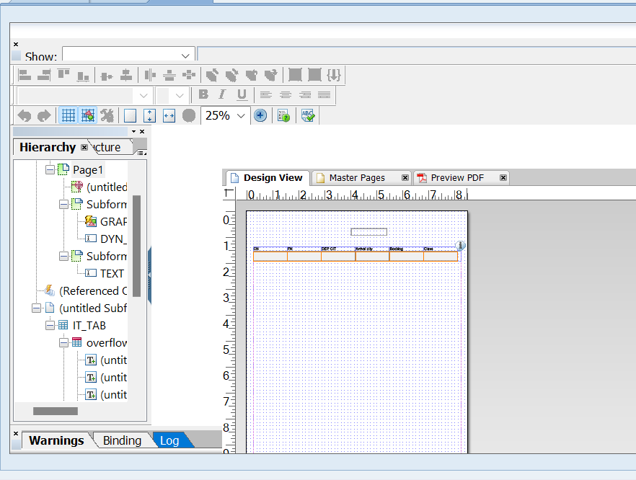

Adobe form output:

